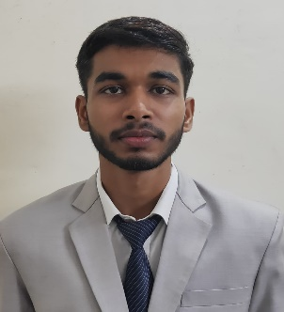

Aayush Kumar Kushwaha

Paste your profession al picture here

Shekhpura ● Ghazipur, 233001

[aayush.kushwaha_mca22@gla.ac.in](mailto:aayush.kushwaha_mca22@gla.ac.in%20) ● +91 8787261481

# 

# EDUCATION

**Master of Computer Application, GLA University, Mathura | (79.6 CPI)** July 2024

**Bachelor of Computer Application, SMS College, Varanasi | (79.63%)** Sept 2022

**Intermediate, St. John’s School, Ghazipur | (59%)** May 2019

**High School, St. John’s School, Ghazipur | (72.16 %)** May 2017

# PROJECTS

**File Converter** April 2023– June 2023

*(Technologies used: HTML, CSS, Javasript, pdf-lib)*

* Developed a web-app for document file conversions from one format to another format.
* Implemented pdf-lib library for conversion part.
* Added pdf merging functionality.

**Stock News Monitoring** Aug 2022 – Sept 2022

*(Technologies used: Python, HTML, CSS, Javascript)*

* Created a web-app to track stock prices and news monitoring
* Designed the frontend using HTML and CSS and backend using python.
* Used AlphaVantage API for stock related data.

# SKILLS

**Technical**

* Programming Languages / Libraries : Java, Python, HTML5, CSS3, JavaScript, MySQL.
* Tools : Git, GitHub.

# Professional

* Ability to learn new skills quickly and efficiently.
* Active listening and effective verbal communication.

# EXTRA/CO-CURRICULAR ACTIVITIES

* Achieved 1st Rank in college and overall 3rd rank in university during graduation.
* Participated in 12 hours non-stop Hackathon (Tech Marathon) held at SMS, Varanasi.
* Workshop on Python Programming and Web Develop by Techup Technologies.
* Activities/Societies : LiveWire Technical Club.

# DECLARATION

I hereby declare that all the above mentioned information is true and correct to the best of my knowledge.